National University of Computer and Emerging Sciences, Lahore Campus

 | Course: | Web Programming | Course Code: | CS-406
 | Program: | BS (Computer Science) | Semester: | Fall 2018
 | Duration: | 180 Minutes | Total Marks: | 40
 | Paper Date: | 19-Dec-18 | Weight | 40 %
 | Section: | A/B | Page(s): | 1 - 7
 | Exam: | Final | Reg. No.
Instruction/Notes: | Question 1 is for students of both sections. Section A is for section A students and Section B is for section B students.  Do not bring any unauthorized material (e.g. written notes, notes in dictionaries, paper, sticky tape eraser etc.) Solve the question on the answer sheets.  Good luck!

Question 1: Following is a snapshot of IMDb (an online database of information related to films, television programs, home videos and video games, and internet streams, including cast, production crew and personnel biographies, plot summaries, trivia, and fan reviews and ratings)
- The home page displays Opening this week and Now playing (Box Office) as follows:

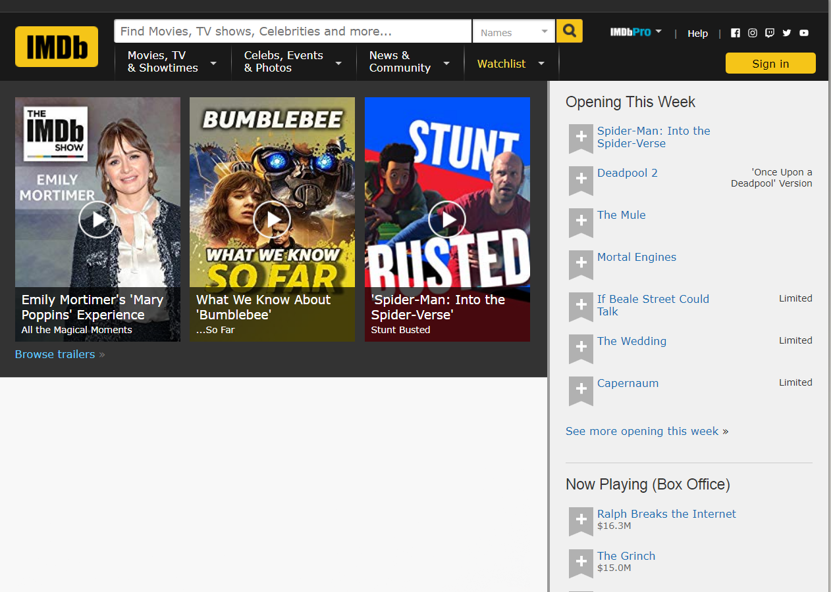

- Clicking on browse trailers redirects the user to a new page which displays the trailers (most popular, most recent, tv tonight) as follows:

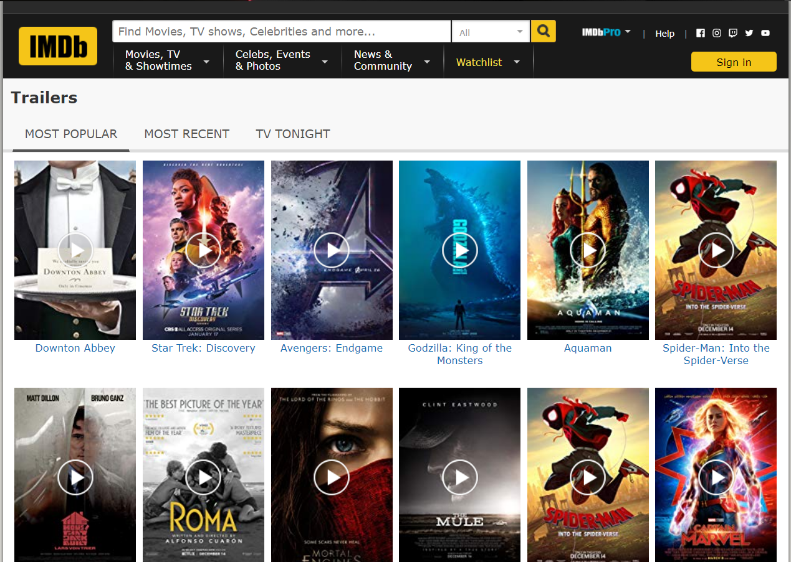

- Performing search by choosing name as “Fantastic Beasts: The Crimes of Grindelwald (2018)” and search field as “Title” redirects the user to the search results page:

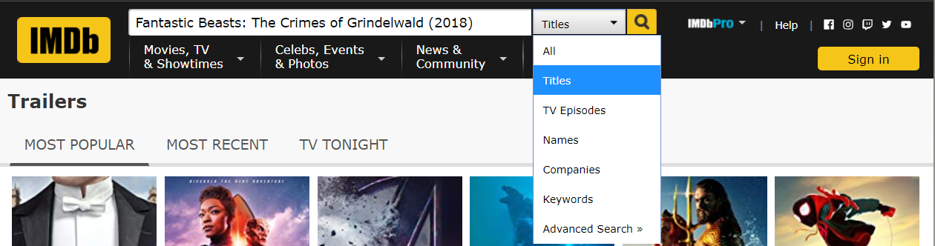

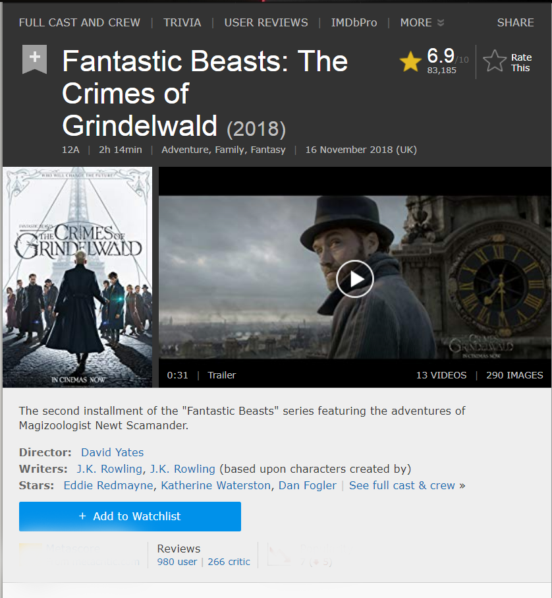

Your task is to work out the back-end architecture that supports these requests using the MVC pattern. The three requests are summarized as follows:
- https://www.imdb.com/Home/Index
- https://www.imdb.com/Home/Trailers
- https://www.imdb.com/Home/SearchResult

- List the MVC based folder structure of your application and mention the file names. (5 marks)
Controller: Home
Views: Home, ItemDetail, SearchResults.
Models: Users.cs, Title.cs , Movie.cs, TvSeries.cs, Person.cs, director.cs, writer.cs, actor.cs, crewmanager.cs, video.cs, trailer.cs, image.cs, Review.cs, Rating.cscategory.cs, critic.cs, episode.cs.
App Data: Database

- Define the schema for the application (5 marks)
Movies (id, title, description, nowplaying, thisweek, director, writer, stars etc)
TvShows (id, title, description, seasonnumbers, director, writer, stars, releasedata etc)
Trailers (id, movieid, tvid, viewcount,releasedate etc)

- Write the code for the middleware that processes these requests and sends appropriate response (6+9+7 marks)

namespace weconnect.Controllers
{
public class HomeController : Controller
{
public ActionResult Index()
{
var openingthisweek = dbcontext.movies.where(t=>onthisweek(t.releasedate)).tolist();
var nowplaying = dbcontext.movies.where(t=>releasedate<DateTime.Now).orderBydescending(t=>t.boxOfficeGross)).tolist();
var trailestoday = dbcontext.movies.where(t=>istoday(t.releasedate)).tolist();
var indexmodel = new indexmodel{ openingthisweek, nowplaying,trailestoday
};
return (indexmodel);

}

public ActionResult Trailers(string f)
{
Datacontext d = new Datacontext();
var trailes = d.movies;
switch(filer){
case "recent": trailers = trailers.orderBy(t=>t.releasedate).tolist();
case "tvtonight": trailers = trailers.where(t=>t.titles.tvtonightAvaiable).orderBy(t=>t.releasedate).tolist();
case "recent": trailers = trailers.orderBy(t=>t.viewcount).tolist();
}
// same for tvshows
viewbag.filer=f;
return (trailers);
}

public ActionResult SearchResult(string n)
{
Datacontext d = new Datacontext();
var q = from x in d.movies where (x.name.equals(n)) select x;
return View(q.tolist());
//same for tvshows trailers
}
}

Section B

- In .net ______WCF______________________ framework is used to implement service-oriented architecture.

- Html Helpers can be of strongly typed as well as non-strongly typed?
- True b) False

- By Default, ASP.Net Session ID is stored in _________.
- Application b) Session
- Cookies d) View State

- What is the last event of web page life cycle?
- Page_Load b) Page_Complete
- Page_Finish d) Page_Unload

- What happens in the Init event of a page?
- View State is loaded on the page.
- Each child control of the page is initialized to its design time values.
- HTML is rendered.
- None of the above.

- What are the advantages of using HTML helpers in MVC? (1)
- It has overloaded methods to pre-populate the values (formatted, and safe for HTML) just like the ViewState.
- It allows built in support for the Validation features of MVC.
- It allows you to override the rendering by providing your own DLL for changing the rendering (a sort of "Controller Adapter" type methodology).

- How can we send multiple objects of different classes from controller to view? Explain using example (1)
Using View Model class.
Public class studentCourse
{
Public student s {set; get;}
Public course c {set; get;}
}

- How Ajax call works? (1)
- User sends a request from the UI and a javascript call goes to XMLHttpRequest object.
- HTTP Request is sent to the server by XMLHttpRequest object.
- Server interacts with the database using JSP, PHP, Servlet, ASP.net etc.
- Data is retrieved.
- Server sends XML data or JSON data to the XMLHttpRequest callback function.
- HTML and CSS data is displayed on the browser.

National University of Computer and Emerging Sciences, Lahore Campus

